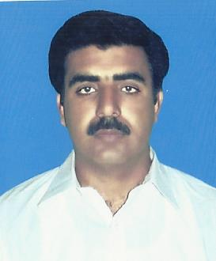
Mailing Address:
Village & Post office Uchhali
Tehsil & District Khushab Punjab Pakistan.
Email:malikhalid999@yahoo.com
Cell No. +966-50-1261241
+92-300-4487618
Khalid Mahmood
(Senior Surveyor)

OBJECTIVE

To grow by actively participating in seeking an opportunity where my skills can be best applied. Proving myself as an active individual of an ever challanging enviroment leading towords growth and development of the organization and maximize my potentials.
Academic Qualification

- Diploma of Civil Surveyor
Skill Developement Council of Pakistan, Islamabad
- D,Com
Punjab Technical Baord Lahore.Pakistan
- SSC
Sargodha Board of Intermediate & Secondary Education, Sargodha Pakistan
Others Courses
- Computer Operator/Office Assistant Course
Uniqe Computer Institute , Khushab Pakistan.
- Auto CAD (2d,3d)
Skill Developement Council of Pakistan, Islamabad
- English Language Course
Biritish Council Lahore.
Work Experience
- Working as a Senior Surveyor in OBAID AL-AWAD AL MUTARI EST. MAKKAH KSA.
From 01-July 2011 to till Date.
- Supervision of Survey Staff & Survey work
- Topo graphic Survey
- Profile Level
- Arrange Coordinate
- Deal with Consultant staff .

- Worked as a Surveyor in Z.K B Construction Company Abbotabad Pakisan
From January 2007 to April 2011.
- Worked as an Asst. Surveyor in Artision Construction Company Lahore. Pakistan.
From Oct. 2004 to Oct 2006
Knowledge & Expertise
- Total Station . (Trimble-S3, Leica-TCR1201, Sokia)
- Level .(Leica, Wild)
- Auto.CAD. Land Desktop 2009, Civil 3D, EW-XP
- Profile Level , Road Designing,
- Responsible of all survey work & survey staff
- Responsible to deal consultant for requests, side inspection, survey etc.
- Office Correspondence, Office Management
- MS Office, MS Word, MS Excel,
- Windows/Software Installations
- Internet

PERSONAL INFORMATION

Name | Khalid Mahmood
Father’s Name | Malik Allah Yar Khan
Religion | Islam
Date of Birth | 09th Oct, 1979
Nationality | Pakistani
Marital Status | Married
Mailing Address | Village & Post Office Uchhali Tehsil &District Khushab Punjab Pakistan.
Telephone (Mobile) | +966-50-1261241, +92-301-5046334
E-mail: | malikhalid999@yahoo.com
Language | English, Urdu, Arabic

